
MY HEALTH SCHOOL

Diet Preference Questionnaire

Name:

Age:

Height: cm Weight: kg IBW:

BMI:
Disease Condition: Diabetes/Non-Diabetic/Pre-Diabetic

Current Symptoms :

Other Clinical / Surgical History :

Supplement: taken/nil

Vegetarian / Non vegetarian: Non vegetarian

South Indian / North Indian: South Indian

Food Allergies/Dislikes: nil

Table of content

Serial number | Content | Page number
1 | Gear 5 Diet | 2
4 | Gear 4 Diet ( Dinner diet) | 7

Gear 5 Diet Chart

"Don't focus on how much you eat. Focus on what you eat."

Diet Plan Created by: Dietitian.
My Health School

Morning | After Waking Up | - After brushing, floss your tongue and Do Oil Pulling with Sesame Oil  - Have 2 Glasses of Lukewarm Water.
Morning Activities before 8 AM | After Waking Up | - Walking / Yoga / Stretches  - Sunbathing and Sun Gazing (Before 7am)  - Have Kashaya (See Recipe Notes)
Morning Breakfast | 8 - 10am Based on your schedule and Fasting Regime. | - Routine breakfast
Mini Fasting | Till Lunch Time | - 4 Hrs Mini Fasting based on your schedule.  - In between the mini fasting detox tea and water is advisable.
Lunch | 12 - 2 PM based on your schedule and Mini Fasting Range | - Routine lunch  - After lunch start to take detox tea upto 6pm
Evening Snacks (Optional) | 4 PM Try to Avoid maximum. Eat only if very Hungry | - After lunch start to take detox tea upto 6pm  - If you are hungry take any Herbal Tea (See Recipe Notes)  - Any Snacks (Eat rarely) (See Recipe Notes)
Early Dinner | 6 PM - 8PM  - After dinner take intermittent fasting  - (Eg: 8pm - next day 9am) | - Kanji recipe with Thuvayal + Salads/ leftover veggies (See Recipe Notes)  - (or) Soups with salad. (See Recipe Notes)  - After dinner take intermittent fasting  - (Eg: 8pm - next day 9am)  - Millet Recipe
Before bed | 9- 10 PM | - Digital Detox (No TV / Mobile /White Lights)  - Triphala 1gm in Half Glass warm water  - Eye wash  - Brushing the Teeth

Routine schedules

Good Sleep | 10 PM - 5 / 6am | - Good Sleep
Daily (Detox tea) | 10 AM- 6 PM | - Detox tea 500ml - 1 liter  - For kidney patients should take detox tea at least 200 ml/day
Daily | 4 - 6 PM | - Walking / Exercise for 20 minutes
Daily (Fasting) | Mini fasting | - In between the meals 4 hours
Daily (Fasting) | Intermittent fasting | - After dinner take 13 hours fasting
Weekly Once | Morning | - Oil bath with Sesame or Coconut Oil
Skin Diet |  | - Cosmetics (No chemical cosmetics like face cream, Powders)  - Use natural face pack powders etc…  - Use Coconut oil soap or Herbal bathing Powder

Fasting Rules

S.No | Do’s | Don'ts
1 | Can Drink water at the time of fasting | Don’t take milk tea,milk coffee,black coffee,black tea,green tea, juices and other solid foods
2 | Only do 4 hours in between the meals | Above 4 hours of min fasting may affect your sugar levels
3 | Only Do 13 Hours fasting. : Not more than that | Above 13 hours of fasting may affect your sugar levels

RRR FOOD CHART
“When diet is wrong medicine is of no use.When diet is correct medicine is of no need”
RRR (Reduce , Restrict , Replace) is a concept which will tell you what all food items you need to reduce , what all needs to be restricted and what alternatives you can use for the restricted products.

Restrict | Reduce | Replace
Fruit Juice, Soda , Cool Drinks or any Energy drinks,More sweeten fruits |  | Whole fruit - 1 per day,Lemon juice without sugar
Any Protein, multivitamin Supplements, Cashew nuts,dates,dry grapes and figs | Roasted and salted almonds,pistachio,peanuts | Eat more of soaked nuts like almond, walnut, seeds and Healthy non veg (No red meats)
White Sugar / Brown Sugar / Sugar free powders,Jaggery Powder , Wild honey , Palm Jaggery (Choose Unadulterated Option),Stevia(Thulasi sugar) | Nil | Take 1 whole fruit / Day
Maida and Maida Products (Cakes , biscuits , puffs , Parotta , noodles,Pizza,Shawarma,Burger etc),  Refined Wheat Products (Gluten can damage your intestinal Walls) |  | Millets - Millet noodles , Millet pasta , millets snacks etc
 | Refined Table salt | Sea salt (Cheap and best) / pink crystal salt (By grinding it make it as a salt powder)
 | White Rice | Millets / Brown rice/Red rice / traditional unpolished Rice
 | Chillies (Red chillies,Mirchi chillies and Green chillies) | Black Peppers
Packaged Foods (Biscuits , snacks, chips , bakery products, Packaged fruits) |  | Green Salads , Whole fruits
Processed Foods (Refined oil , Palm oil etc) |  | Wood Pressed oils , Sea salt , millets powder etc
 | Late night parties , cinema ,Tv . mobile phone. | Schedule early afternoons .

Gear 4 Diet Chart

"Don't focus on how much you eat. Focus on what you eat."

Weekly chart

Days | Kashayam (Compulsory)  Timing : 7 - 8 am | Herbal tea/Snacks (Optional)  Timing : 4pm
Day 1 | Drumstick leaves kashayam | Boiled green gram sundal/Lemon tea
Day 2 | Tulsi leaves kashayam | Boiled black chana
Day 3 | Coriander kashayam | chickpea chat/Lemongrass tea
Day 4 | Drumstick leaves kashayam | Boiled green gram sundal
Day 5 | Tulsi leaves kashayam | Boiled black chana/Tulsi tea
Day 6 | Coriander kashayam | Makhana chat
Day 7 | Drumstick leaves kashayam | Boiled groundnut/Lemon tea

Weekly chart for weight gain (Non - veg)

Days | Dinner
Day 1 | Millet idli with chicken kulambu + chicken soup
Day 2 | Kanchi recipe with thuvaiyal + salad
Day 3 | Millet dosa with Sambhar + veg poriyal
Day 4 | Kanchi recipe with thuvaiyal + mushroom soup
Day 5 | Millet chapathi with veg kurma + salad
Day 6 | Kanchi recipe with thuvaiyal + veg poriyal
Day 7 | Millet idli with Fish kulambu + prawn soup

Weekly chart - weight loss (Non - Vegetarian)

Days | Dinner
Day 1 | Kanchi recipe with thuvaiyal + salad
Day 2 | Millet idli with chicken kulambu + chicken soup
Day3 | Kanchi recipe with thuvaiyal + veg poriyal
Day 4 | Millet chapathi with veg kurma + salad
Day 5 | Kanchi recipe with thuvaiyal + mushroom soup
Day 6 | Mixed millet idli with fish kulambu + veg poriyal
Day 7 | Kanchi recipe with thuvaiyal + salad

Recipes

"Turn your food into medicine and you won't need medicines anymore.”

Important Note: If any dizziness or fatigue during the interval of meal time.Kindly let us know about the condition.According to that we will change your meal plan.

Kashayas
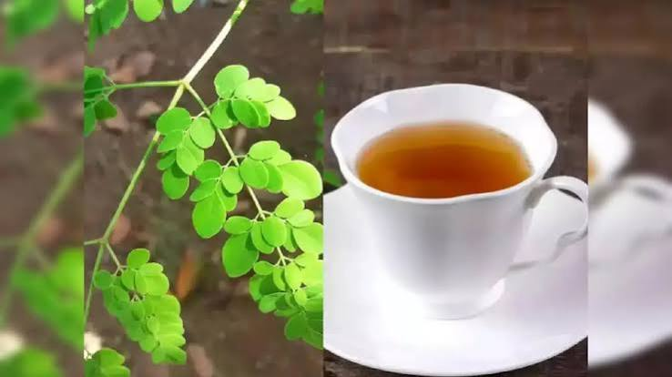
Option 1 : Drumstick leaves Kashayam
- Take ½ fistful of drumstick leaves
and wash well.
- Then take 200 ml of water and let it boil.
- Add the washed drumstick leaves
in the boiling water and wait for 5 minutes.
- Then filter and have it empty stomach

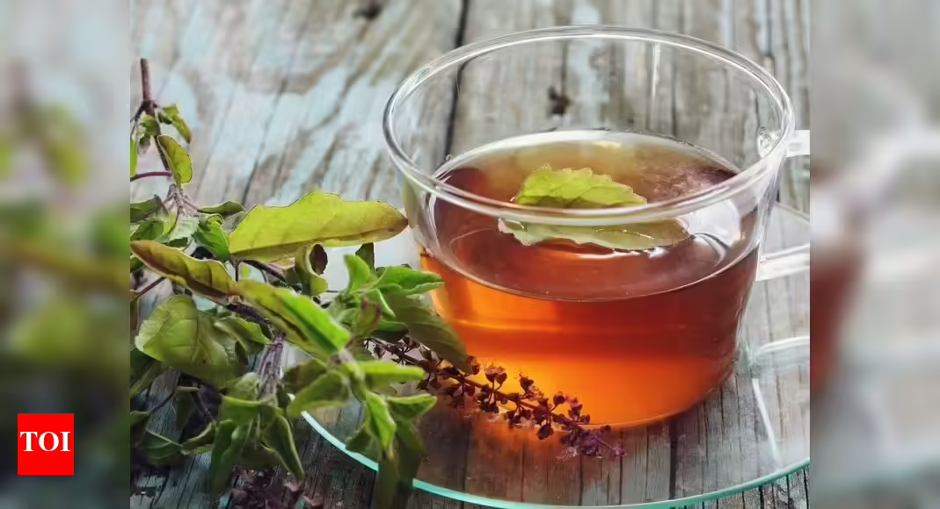
Option 2: Tulsi (Holy Basil) Leaf Kashayam
- Take a handful of Tulsi (Holy Basil) leaves and wash them thoroughly.
- Boil 200 ml of water.
- Add the washed Tulsi leaves to the boiling water.
- Let it boil/steep for 3–4 minutes.
- Strain and drink it on an empty stomach.

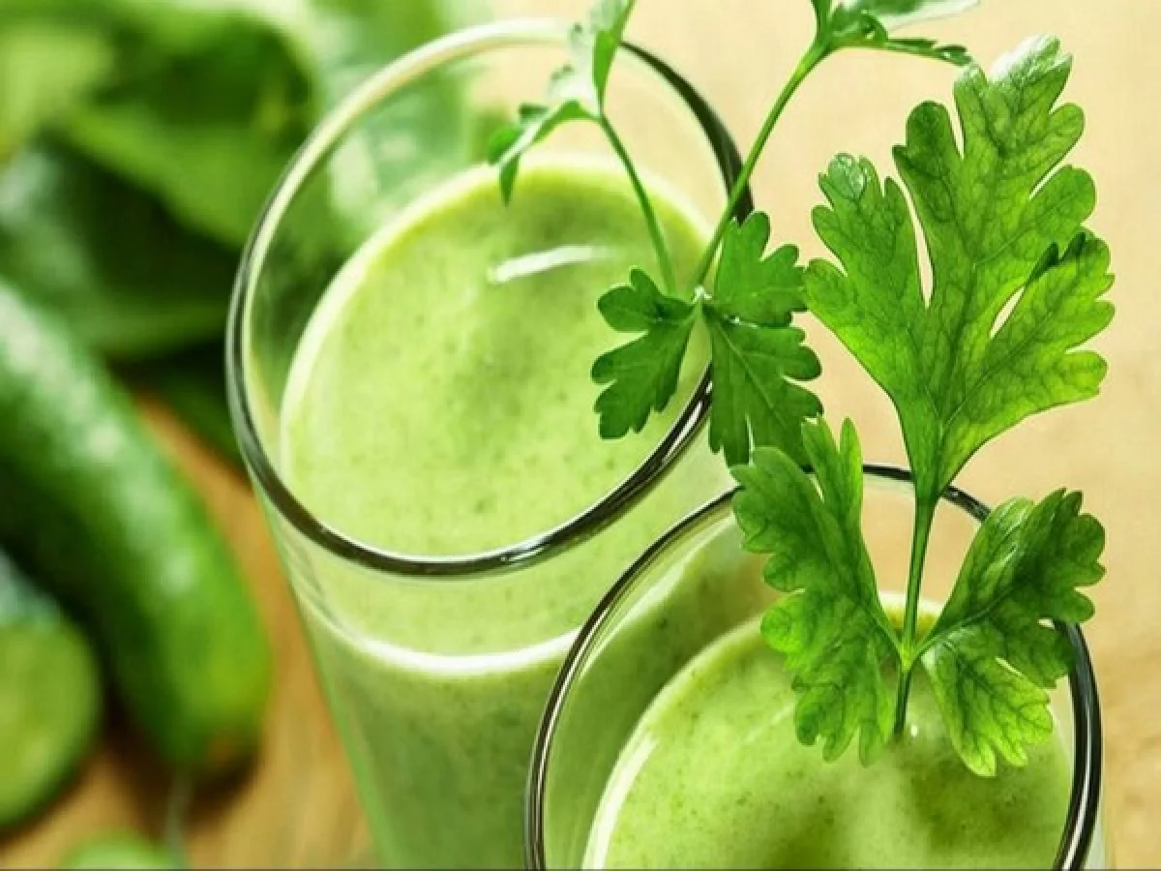
Option 3: Coriander Leaf Kashayam
- Take a handful of coriander leaves and wash them thoroughly.
- Boil 200 ml of water.
- Add the washed coriander leaves to the boiling water.
- Let it boil/steep for 3–4 minutes.
- Strain the decoction and drink it on an empty stomach.

Snacks

Option 1- Makhana Chat

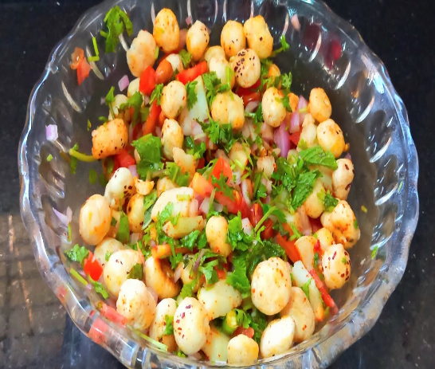
Ingredients:
- Makhana (lotus seed)- 20 gms
- Onion
- Tomato
- Cucumber
- Roasted groundnut
- Pepper powder

Recipe:
- Dry roast makhana in pan
- Then transfer it to a bowl, now add chopped onion, tomato, cucumber roasted groundnut and pepper powder to it.
- Mix well and serve

Option 2- Chickpea chat
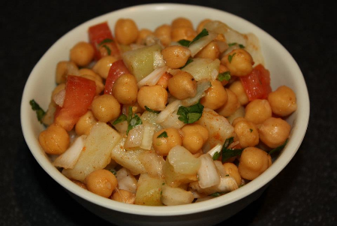
Ingredients
- Boiled Chickpea ½ cup
- Onion
- Tomato
- Cucumber
- Grated raw mango
- Pepper
- Jeera powder
Recipe

- Add the boiled chickpea to a bowl
- Now add chopped onion, tomato, cucumber, grated raw mango, jeera powder and pepper powder to it.
- Mix well and serve

Option 3- Boiled green gram

Option 4- Boiled Black channa

Option 5 - Boiled groundnut

Herbal Tea

Option 1 : Lemon Tea
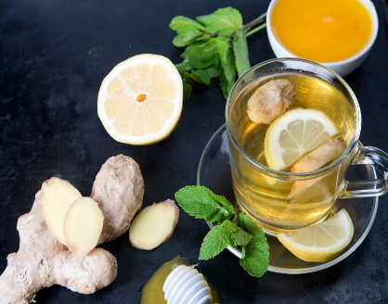
Ingredients:
- 1 cup water
- 1 teaspoon loose black tea leaves or 1 tea bag
- 1 tablespoon fresh lemon juice (adjust to taste)
- 1-2 teaspoons honey or sweetener of
your choice (optional)
- Lemon slices for garnish (optional)
- Mint leaves for garnish (optional)

Instructions:
1. In a small saucepan, bring one cup of water to a boil.

2. Add the black tea leaves or tea bag to the boiling water and let it steep for 2-3 minutes (or according to the package instructions) on medium heat. Steep longer if you prefer a stronger tea.

3. While the tea is steeping, cut a fresh lemon in half and squeeze out one tablespoon of lemon juice. Adjust the amount to suit your taste preference.

4. After steeping, remove the tea leaves or tea bag from the water and discard them.

5. Switch off the Gas. Add the fresh lemon juice to the brewed tea. If you like your tea sweetened, you can add honey or your preferred sweetener at this stage. Stir well until the sweetener dissolves.

6. Pour the lemon tea into your favorite teacup.

7. Optionally, you can garnish the tea with lemon slices and mint leaves for a refreshing touch.

8. Enjoy your hot and revitalizing lemon tea!

Option 2 : LemonGrass Tea

Ingredients:
- 3 cups water
- 2 stalks of lemongrass, bruised or chopped
- 1-inch piece of fresh ginger, thinly sliced
- 1 cinnamon stick
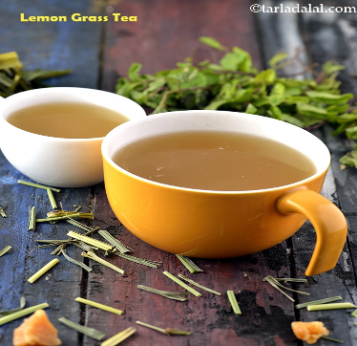
Instructions:

1. In a saucepan, bring 3 cups of water to a boil.

2. Add the lemongrass, ginger slices, and cinnamon stick to the boiling water.

3. Reduce the heat to low and let the mixture simmer for about 10-15 minutes. This will allow the flavors of lemongrass, ginger, and cinnamon to infuse into the water.

4. Switch the Gas off., remove the saucepan from the heat and strain the tea into a teapot or another heat proof container to remove the lemongrass, ginger, and cinnamon pieces.

5. Garnish with a spring of fresh mint if desired.

6. Enjoy your delightful lemongrass, ginger, cinnamon tea!

This aromatic tea is not only delicious but also has potential health benefits from the lemongrass and ginger, making it a fantastic choice for relaxation and rejuvenation.

Important note:
To prepare lemongrass tea at home, obtain lemongrass stalks from a nursery store, and plant them in a sunny area with well-drained soil. Keep the soil moist and trim the stalks regularly for fresh leaves, perfect for brewing homemade lemongrass tea.
Option 3 : Tulsi Tea
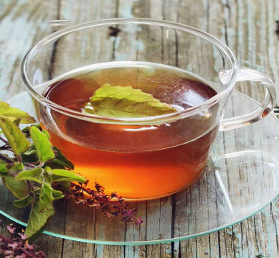
Ingredients:
- Fresh Tulsi (holy basil) leaves or dried Tulsi leaves
- Water
- Optional: Cinnamon, ginger for
added flavor (if desired) Preparation:
- Boil water in a pot.
- If using fresh Tulsi leaves, wash them thoroughly. If using dried leaves, measure out the desired amount.
- Add the Tulsi leaves to the boiling water.
- Optionally, add cinnamon or ginger for additional flavor.
- Let the mixture simmer for 5-10 minutes to allow the flavors to infuse.
Strain and Serve:
- Once the tea has infused, strain out the Tulsi leaves (and any other added ingredients).
- Pour the tea into a cup.
- Drink the Tulsi tea warm.
Tulsi contains compounds like eugenol, which may help regulate blood sugar levels by enhancing insulin secretion and sensitivity. Consuming Tulsi tea regularly may help stabilize blood glucose levels.

Important note:
To prepare Tulsi tea and plant a Tulsi plant at home, just sow Tulsi seeds in a sunny spot with well-draining soil, water regularly, and pluck the leaves for brewing when they're mature.

Dinner Recipes

Important Note:
Eat until you reach satiety, ensuring you consume enough food to satisfy your hunger and nutritional needs.

Kanji:

Little Millet / Kodo Millet / Barnyard / Foxtail ( Everyday take 1 millet )
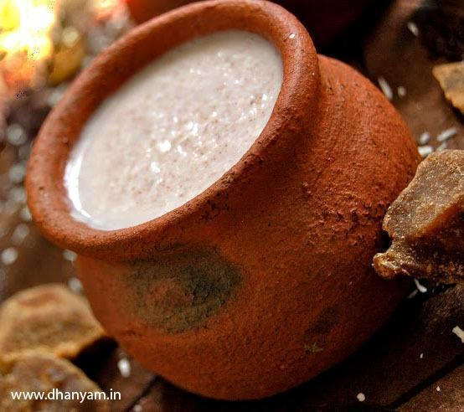
Recipe:
- Coarsely grind Any 1 Millet in a mixer jar in pulse mode just for 2 sec.
- Wash it with water and drain the water using the filter.
- For 1 glass of Millet add 10 glasses of water and let it soak for 8 hours .
- Then in the morning take a mud pot, fill it with the same millet soaked water and let it boil.
- Once the water starts boiling add the soaked millet and stir well.
- Cook till it gets thicker and soft consistency
- Switch Off the flame and let it cool for half an hour.
- Then cover the entire mud pot with cotton cloth.
- Let it ferment for 8 hours
- You can add salt after fermentation
- Then you can take that kanji for dinner.

Thuvaiyal Recipes for kanji
Option 1 : Mixed Paruppu thuvaiyal
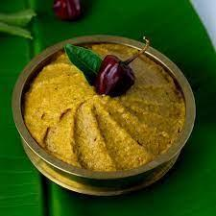
Ingredients:
- Bengal gram dal
- Toor dal
- Urad dal
- Coconut
- Dry chilli
- Garlic cloves
- Tamarind
- salt
Recipe:
- Dry roast all dal in pan till golden brown
- Then add in the mixy jar add grated coconut, dry chilli, garlic, tamarind and salt
- Grind well into a thick paste with little water.

Option 2 : Ridge gourd thuvaiyal
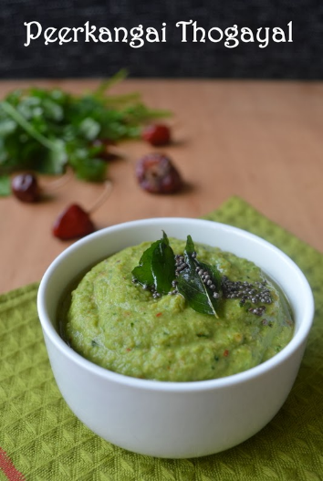
Ingredients:
- Ridge ground
- Urad dal
- Coconut
- Red chilli
- Tamarind
- salt

Recipe:
- Chop the ridge gourd without peeling it.
- Add little coconut oil and saute the chopped ridge gourd, grated coconut, dry chilli
- Then transfer the sauted ingredients into the mixy jar and some tamarind salt and grind it.

Option 3 : Groundnut thuvaiyal
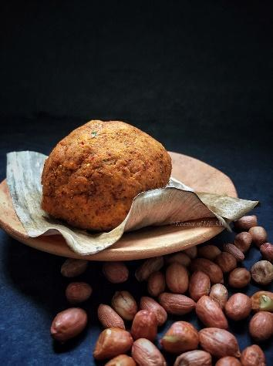
Ingredients:
- Groundnut
- Red chilli
- Tamarind
- Garlic cloves
- salt

Recipe:
- Dry roast the groundnut and peel out the skin
- Dry roast the red chilli and garlic for 30 seconds
- Add all the dry roasted ingredients into the mixie jar.
- Then add some tamarind and salt and grind well.

Option 4: Vazhaipoo thuvaiyal
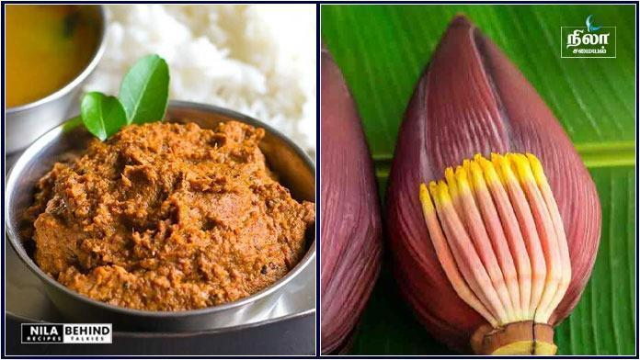
Ingredients:
- Vazhaipoo
- Tamarind
- Coconut
- Urad dal
- Red chilli
- salt

Recipe :
- Add some water and boil the chopped vazhai poo for 5 mints
- Then add little coconut oil and saute coconut, urad dal, red chilli and boiled vazhaipoo just for 30 sec.
- Then transfer it to a mixie jar
- Add some tamarind & salt grind well
Option 5 : Pirandai thuvaiyal
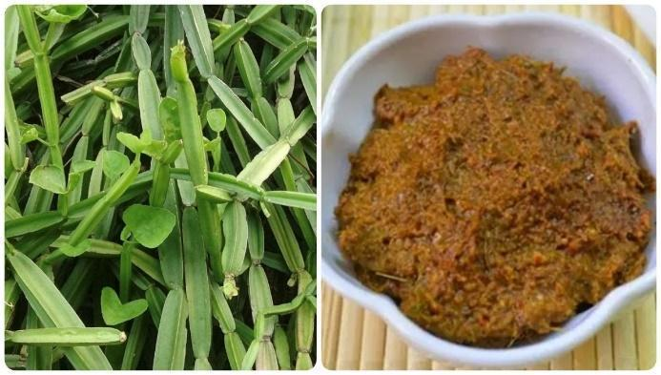
Ingredients:
- Pirandai
- Onion
- Bengal gram dal
- Coconut
- Dry chillies
- Tamarind
- Asafoetida
- salt

Recipe:
- Clean and chop pirandai into small pieces. Remove the outer skin layer.
- Then add some coconut oil and saute dry chilli, onion, bengal gram dal, asafoetida and onion.
- Then transfer it to mixy jar and add some tamarind & salt
- Then grind well into a smooth paste.

Dinner Millet Recipes

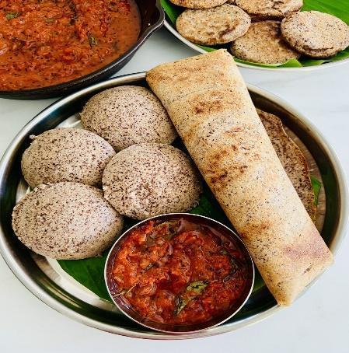
Option - 1: VARAGU IDLI DOSA
1 cup = 250ml
Varagu/Kodo millet - 1 cup
Round urad dal - 1/4 cup
Methi seeds/Vendhayam - 1/4 tsp
salt and water - as needed
HOW TO MAKE VARAGU IDLI DOSA - METHOD
- Take all the ingredients given above except salt and wash them twice in water to remove the debris. Soak it together for 4 hours.
- Grind them and add enough salt & water. Please do not add more water because they can be easily ground in less water. So use water only when needed. The consistency of batter should be like our regular idli batter.If the batter is too watery, you cannot make idlis. Idli will be flat and sticky. If you add very little water, idli will be hard. So take care while adding water.
- Ferment it overnight or minimum 16 hours ( if it is winter). The next morning, the batter would have risen in volume but not doubled.
- Stir the batter well with a ladle and make idlis. Steam it in an idli pot for 10 minutes. Check with a back of spoon or using fingers dipped in water. If it comes out clean, idli is cooked. Remove with a spoon and serve hot !

Note
- No need to add rice in this recipe.
- Do not add more water while grinding.
- Idlis come out soft for varagu and dal in 5 :1 ratio. If you want even more softness, use a 4:1 ratio based on the quality of dal.
- Adding methi seeds is for softness. Don’t skip it.
- Ferment the batter for a minimum of 12 hours. During summer 8 hours is enough.
- Use the same cup for measuring all the ingredients.

Option - 2: Kambu/ Bajra/ Pearl millet idli recipe
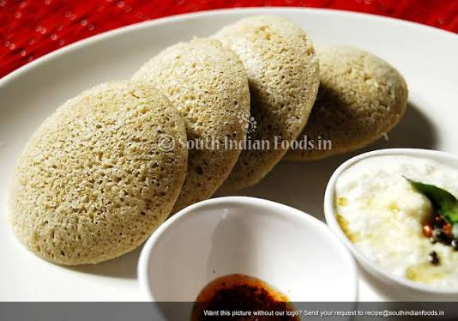
INGREDIENTS
1 cup - 240ml
- Pearl millet / Kambu / Bajra - 2 cups
- White,round urad dal - 1/2 cup
- Methi seeds / Fenugreek seeds - 1/2 tsp (Optional)
- salt & Water - As needed

HOW TO MAKE PEARL MILLET IDLI
1. Wash and soak pearl millet, methi seeds together for 5 hours.
2. Wash and soak urad dal separately in another bowl for 2 hours.
3. Grind urad dal to a smooth paste adding the soaked water.
4. Collect in a bowl and then grind millet, adding enough water.
5. Mix both the batter with your hands and let it ferment overnight. The next day, mix the batter well and make idli.
6. Enjoy with tomato chutney

Dinner - Soups Recipe

Non Veg Options:

Option 1 : South Indian Shrimp Soup (Prawn Rasam):
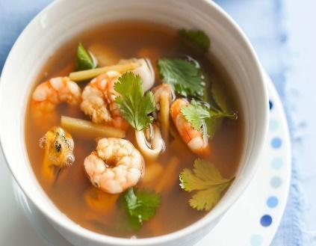
Ingredients:

- 1/2 pound medium-sized shrimp, cleaned
and deveined
- 1 small onion, finely chopped
- 1 small tomato, chopped
- 1 teaspoon ginger-garlic paste
- 2-3 green chilies, slit
- 1/2 teaspoon turmeric powder
- 1 teaspoon rasam powder (South Indian spice blend)
- A small piece of tamarind (soaked in water)
- Few curry leaves
- Fresh coriander leaves for garnish
- salt to taste
- Water

Instructions:

- In a pot, bring the cleaned shrimp and 2 cups of water to a gentle simmer. Cook the shrimp for about 2-3 minutes until they turn pink and are cooked through. Remove the shrimp from the water and set them aside.
- In the same pot, add chopped onion and sauté until it becomes translucent.
- Add ginger-garlic paste and slit green chilies. Sauté for another minute until fragrant.
- Add chopped tomato and cook until it becomes soft.
- Add turmeric powder and rasam powder. Mix well.
- Pour in tamarind water (strained from the soaked tamarind). Adjust the quantity based on your taste preferences.
- Add curry leaves and salt. Let the rasam simmer for about 5-7 minutes to allow the flavors to meld.
- Add the cooked shrimp back to the pot and let it heat through in the rasam.
- Garnish with chopped fresh coriander leaves.
- Serve the South Indian Shrimp Soup (Prawn Rasam) hot as a tangy and flavorful soup.

Option 2 : Chicken soup

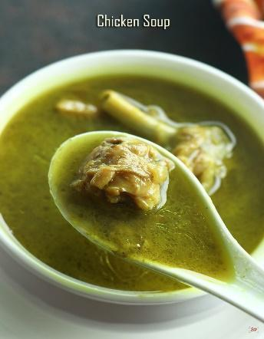
Ingredients:
- Chicken (200 gms)
- 1 small onion, finely chopped
- 1-2 garlic cloves, minced
- 1-inch piece of ginger, grated
- 1 green chili, finely chopped
- Few curry leaves
- salt to taste
- Water

Instructions:
1. In a pot, add the chicken pieces, onion, garlic, ginger, green chili, and curry leaves. Pour enough water to cover the vegetables and bring it to a boil.

2. Simmer the soup until the chicken is soft and cooked.

3. Add pepper powder and coriander leaves.

4. Add salt to taste, stir well, and serve the Chicken soup hot. It's a vibrant and flavorful option packed with essential nutrients.


Option 3 :Goat leg (Aatukaal) soup:

Ingredients:

- 1 goat leg (paya), cleaned and cut
into pieces
- 1/4 small onion, chopped
- 1 small tomato, chopped
- 1 teaspoon ginger-garlic paste
- 1/4 teaspoon turmeric powder
- 1/4 teaspoon cumin powder
- 1/4 teaspoon black pepper powder
- salt to taste
- Water
- Fresh coriander leaves, chopped (for garnish)

Instructions:
- Wash the goat leg thoroughly under cold water.
- In a pressure cooker add the washed goat leg
- Then add chopped onion, tomato, turmeric powder, ginger garlic paste,salt and water.
- Then pressure cook it for 6-8 whistles and switch off the flame.
- Then add the pepper and cumin powder and allow it to boil for another 10-15 minutes in low flame.
- Ladle the hot goat leg soup into a serving bowl.
- Garnish with chopped fresh coriander leaves.
- Serve it hot

Veg Soup Options

Option 1 :Turmeric Lentil Soup:
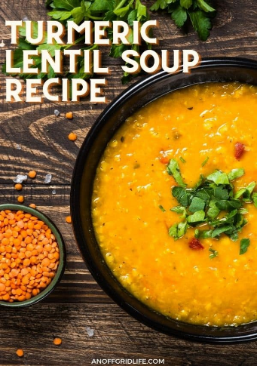
Ingredients:
- 1 cup toor dal, rinsed and drained
- 1 onion, chopped
- 2 carrots, chopped
- 3 cloves of garlic, minced
- 1 teaspoon ground turmeric
- 1 teaspoon ground cumin
- 1/2 teaspoon ground coriander
- 1/4 teaspoon ground cinnamon
- 1/2 cup diced tomatoes
- salt and pepper to taste

Instructions:.
1. Add the chopped onions, carrots tomatoes in a pot and add water, make it to boil
2. While boiling,add the minced garlic, ground turmeric, ground cumin, ground coriander, and ground cinnamon.
3. Add the red lentils to the pot and stir to combine with the vegetables and spices.
4. Reduce the heat to a simmer and let the soup cook for about 20-25 minutes, or until the lentils are tender and cooked through.
5.Season the soup with salt and pepper to taste..
6. Serve the turmeric lentil soup hot, garnished with chopped fresh coriander .

Option 2 : Tomato and Bell Pepper Soup:

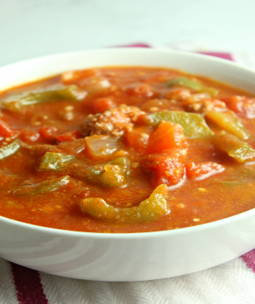
Ingredients:
- 2 large tomatoes, chopped
- 1 red bell pepper, chopped
- 1 small onion, chopped
- 2 cloves garlic, minced
- 1/2 tsp cumin seeds
- 1/4 tsp turmeric powder
- salt and pepper to taste
- Water or vegetable broth

Instructions:
1. In a pot add chopped onion,tomatoes and red bell pepper.
2. Add enough water to cover the ingredients. Bring to a boil and then simmer for a few minutes.
3. Then add paprika turmeric powder, salt, and pepper. Mix well
4. Blend the soup to your desired consistency using an immersion blender or regular blender.

Option 3 : Mixed Vegetable Clear Soup

Ingredients:
- Assorted vegetables (carrots, beans, peas, corn, etc.), chopped
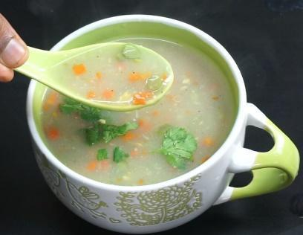
- 1 small onion, finely chopped
- 2-3 garlic cloves, minced
- 1-inch piece of ginger, grated
- 1-2 green chilies, finely chopped
- Few curry leaves
- 1/2 teaspoon black pepper powder
- salt to taste
- Water

Instructions:
1. In a pot, add the chopped vegetables, onion, garlic, ginger, green chilies, and curry leaves. Pour enough water to cover the vegetables and bring it to a boil.

2. Let the soup simmer until the vegetables are cooked but still retain their crunch.

3. Add black pepper powder and salt to taste. Stir well and serve the clear vegetable soup piping hot. It's a nutritious and comforting option for any time of the day.

Option 4 : Mushroom and Fenugreek soup:

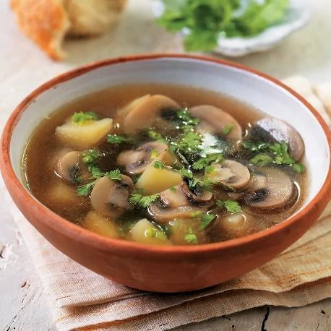
Ingredients :
- Mushroom
- Fenugreek leaves
- Garlic
- Ginger
- Cumin
- Coconut milk

Recipes:
- Add sliced mushrooms and fenugreek leaves in a pot Add water and diced tomatoes.
- Let it to boil
- Then add ginger, garlic, cumin, and a touch of coconut milk.
- Then serve in a bowl with chopped coriander leaves on the topping

Option 5 : Mint and Coriander Soup:

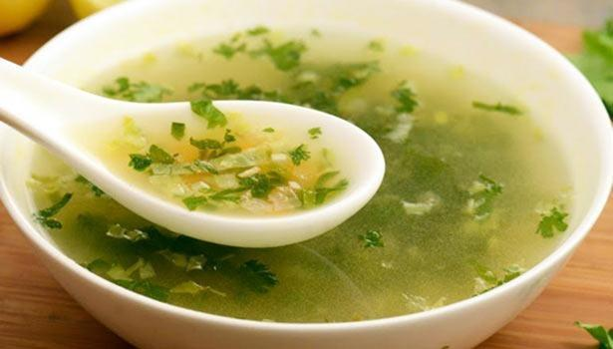
Ingredients:
- 1 cup fresh mint leaves
- 1 cup fresh coriander leaves
- 1 small onion, chopped
- 2 cloves garlic, minced
- 1 small potato, diced
- 1/2 tsp cumin seeds
- 1/2 tsp ground coriander
- 1/4 tsp turmeric powder
- salt and pepper to taste
- Water or vegetable broth

Instructions:
- In a pot add the chopped onion, garlic, diced potato, ground coriander, turmeric powder, salt, and pepper
- Add enough water or vegetable broth to cover the ingredients. Bring to a boil and then simmer until the potato is cooked.
- Add fresh mint leaves and coriander leaves. Simmer for a few more minutes.
- Blend the soup to a smooth consistency using an immersion blender or regular blender.

Option 6 : Banana stem soup
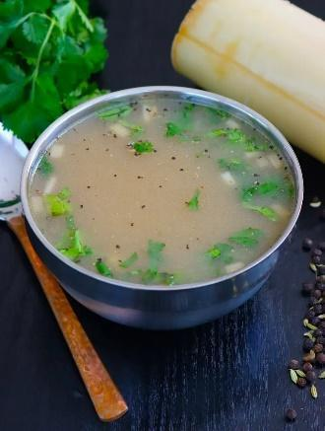
Ingredients
- 1 cup Banana stem chopped
- 2 garlic cloves
- 1 small piece ginger
- ½ green chilli
- ¼ teaspoon fennel seeds
- 2 teaspoon coconut oil
- salt & pepper as needed

Instructions
- Clean vazhaithandu by taking out the excess strips around it by peeling off the thick ones. Slice off the thin outer ring (it will be opaque comparatively). Chop roughly into cubes and measure 1 cup.
- Gather other ingredients.
- Heat a small pressure cooker with coconut oil.
- Add fennel seeds, ginger, garlic, chilli and fry for a minute.
- Banana stems and little salt. Cook for one more minute.
- Add 1 cup water and pressure cook for 3 whistles.
- Once done, take out ginger, green chilli. Strain the ingredients for cooling down. Reserve the cooked water.
- Once cooled, blend smoothly with little saved water.
- Filter through a metal strainer.
- Adjust salt.
- Heat until it boils and continue simmering for a minute.

Option 7:Broccoli soup:
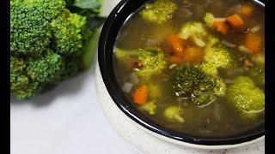
Ingredients :
- Broccoli
- Tomatoes
- Garlic
- Ginger
- Cumin
- Coconut milk

Recipes:
- Add broccoli in a pot Add water and diced tomatoes.
- Let it to boil
- Then add ginger, garlic, cumin, and a touch of coconut milk.
- Then serve in a bowl with chopped coriander leaves on the topping

Fruits Law

- Do not mix fruits. It is always best to take 1 fruit at a time.
- Morning time is best to take fruits . Avoid at night because it may lead to disturbed sleep or may increase cold and mucus formation.
- Do not eat fruit along with other foods like rice or vegetables. It will lead to digestion issues.
- Diabetes Patients - take fruits as advice by your Doctor or physicians.
- In any situation you want to take fruits in between, always have a gap of 1 hr between your fruits and next meals.
“Take care of your body. It’s the only place you have to live.” – Jim Rohn

Disclaimer: As a dietician and part of My health School, I offer dietary recommendations and suggestions to improve your health, especially for individuals with specific medical conditions. However, it is important to understand that these dietary suggestions are not intended to replace or serve as an alternative to your prescribed medications or medical treatments. My recommendations are meant to complement your existing medical care and enhance your overall health and well-being.

I strongly advise against discontinuing any prescribed medications or medical treatments without consulting your primary medical practitioner. Always seek the guidance of a qualified healthcare professional if you are considering making any changes to your medical treatment plan.

